Holding Classes on Microsoft Teams

Instructors

Scheduling a Teams meeting
- Open Microsoft Teams.
- Click the Calendar tab
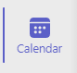
- To schedule a meeting, click New Meeting
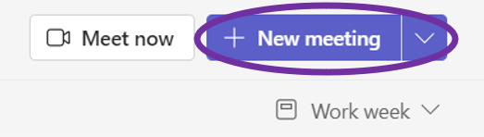
- Give your meeting a title. Leave attendees blank for now. Set dates and durations of your class
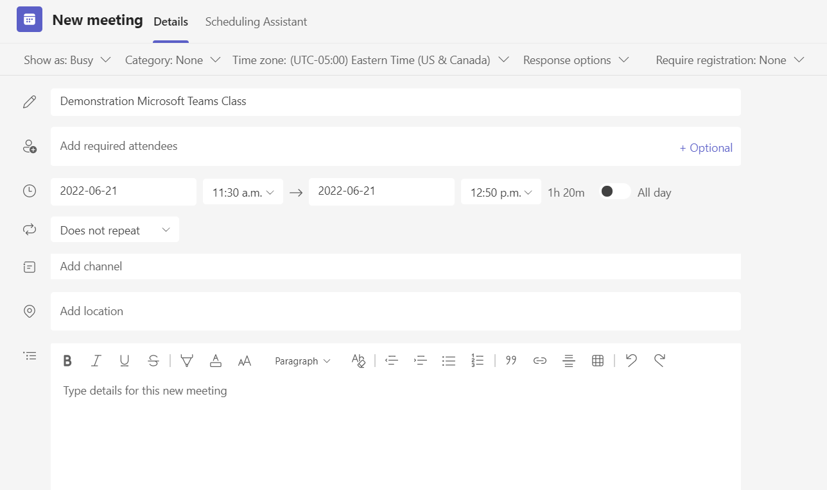
- Set your scheduled class to repeat
  - Open the dropdown for repetition shown here
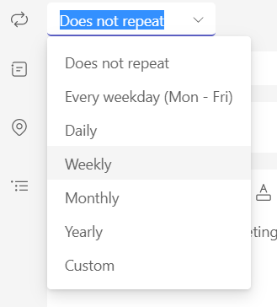
  - Set the repetition to what is appropriate for your course, likely weekly
  - Select days of the week and an end date for your class
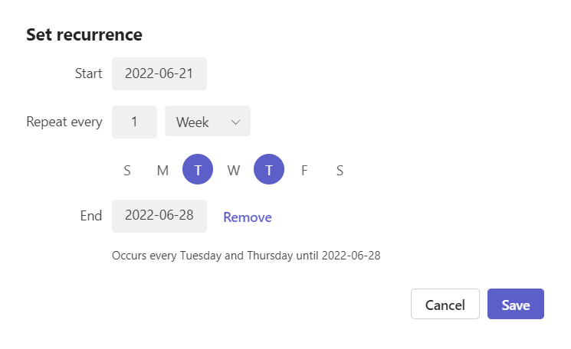
  - Click Save in this dialogue box and then click Save again in the meeting creation dialogue box.
  - Your class will now appear in its scheduled time slot in your Teams calendar alongside other meetings and events.
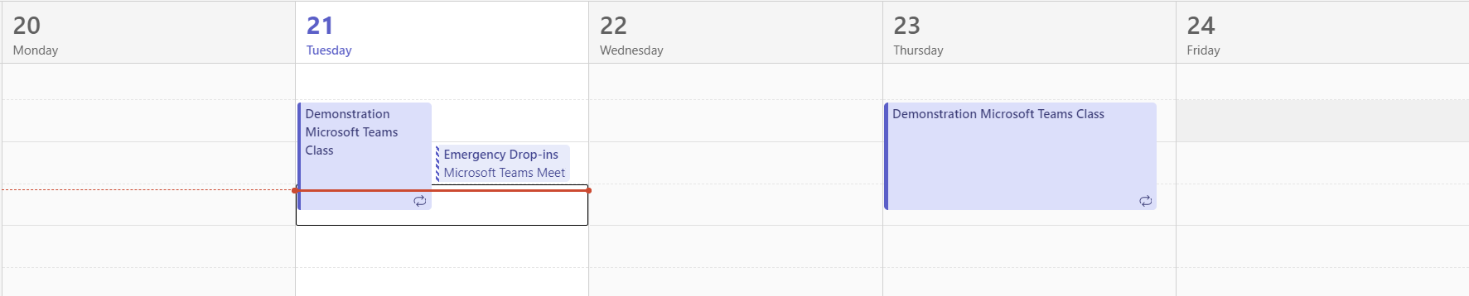
- To join this class, click on today’s occurrence of it in your calendar. In the pop-up, click Join.

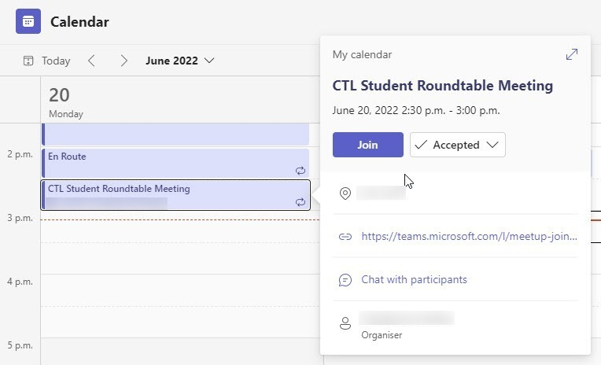
- From here, skip to the steps outlined in Inviting Students to your Teams Meeting

Starting a Teams meeting
- Open Microsoft Teams.
- Click the Calendar tab.
- Click Meet now.

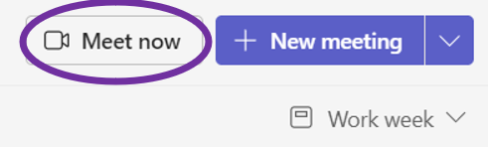
- Enter a title for the meeting and click Start meeting.
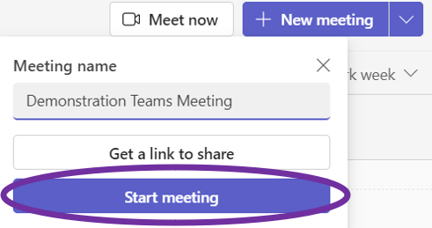
- Click Join now.

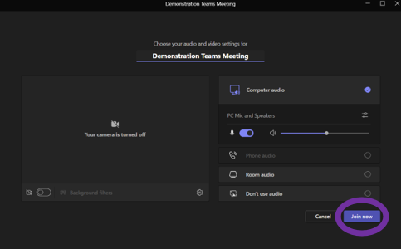

Inviting students to your Teams meeting
- Click Copy meeting link. A checkmark will appear and ‘Copied to clipboard’ will display.

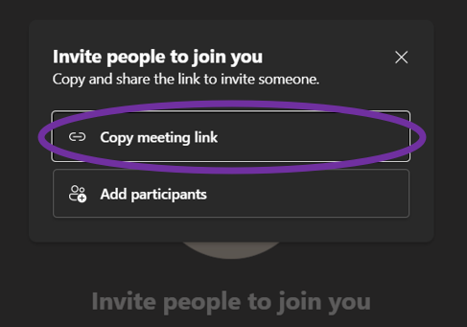
- Open the Outlook app.
- Create a New Email
- In the To line, begin typing the course code of the course you want to send the code to
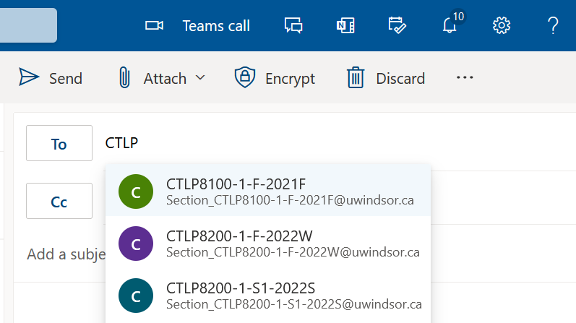
- In the dropdown list that appears, select the appropriate course.
- Paste the link you copied into the email body.
- Send the email to your students. They will be able to use this link to join your meeting.

