Using Microsoft Teams Assignments – For Instructors
Microsoft Teams offers a feature that allows instructors to create assignments for their students. This document will help instructors get a better understanding of how to create an assignment.

Creating an assignment in Teams
- Open your Microsoft Teams app or login using the web app.
- Click on the Teams icon located on the left and then click on whichever team you would like to make the assignment for.
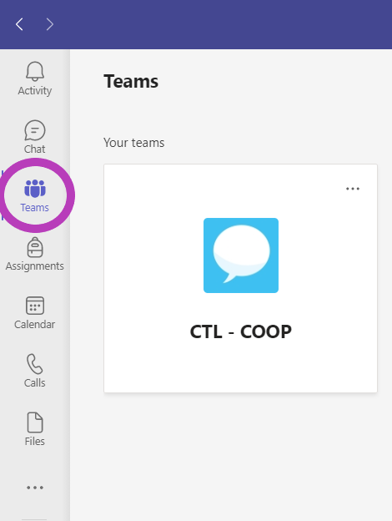

- Click on the Assignments tab and then click on Create.
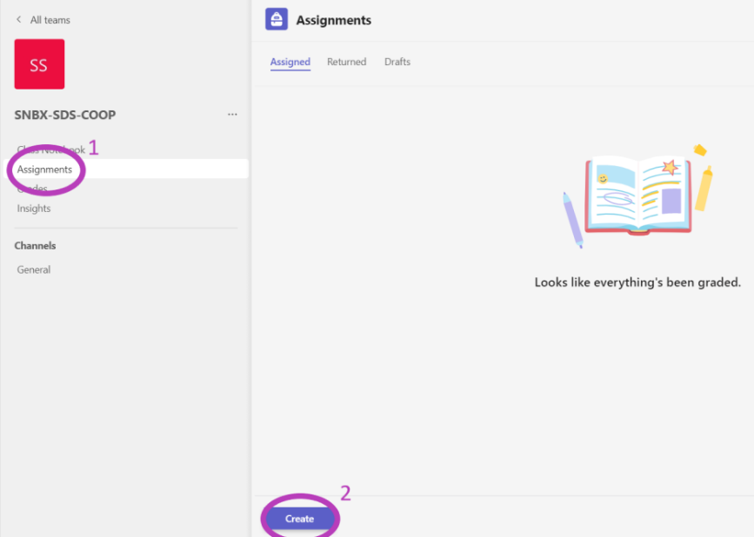

- Once you click Create you will be given three options: Assignment, Quiz, and From existing. There is a brief overview of each option below but in our case, we will select Assignment.

Assignment – Start from scratch and upload your own assignment.
Quiz – Uses Microsoft Forms to create a quiz for the students.
From Existing – Use a previously created assignment.
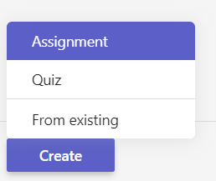

- Now you can include your basic information like description of the assignment and add a rubric. You can also upload your assignment file here. Once everything is added you can click the Save button located at the top right.
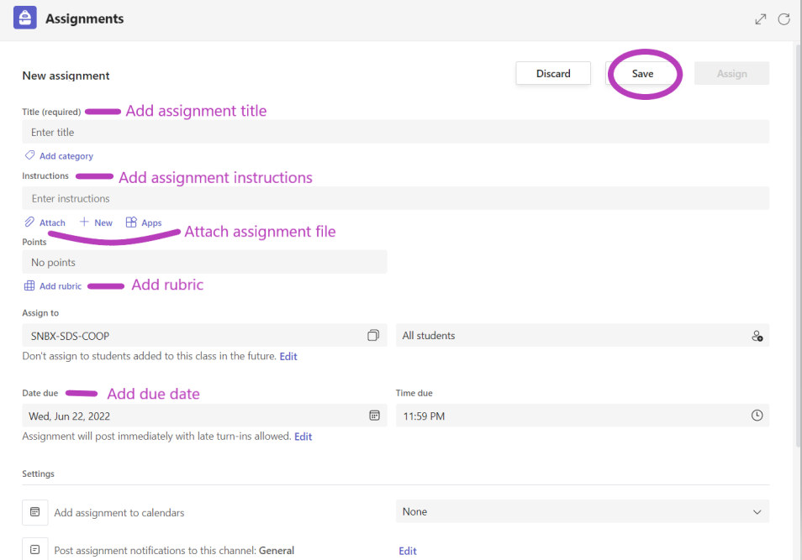

Your assignment has now been created. You can view the assignment in the Assignments tab.

